ou are given two DNA sequences consisting of the uppercase english characters A, G, T and C. In the classical sequence alignment problem, the alignment cost is calculated based on three factors: match (when the same characters from both sequences are aligned), mismatch (when different characters are aligned), and gap (when a character is aligned with a space).
In this variation of the problem, the gap cost is modified. Specifically, when multiple consecutive spaces are aligned together in one sequence, the cost for this segment of m spaces is calculated as m^2⋅(gap cost) rather than just m⋅(gap cost). These space segments must be maximal, meaning there must not be any additional spaces to the left or right of the segments in the corresponding sequence after the alignment.
Given two sequences and the costs for a match, a mismatch, and a gap, your task is to determine the maximum possible alignment cost between these two sequences using the modified gap cost rule.

Standard input
The first line of input contains an integer n, the length of the first sequence.
The second line of input contains a string a of length n, the first sequence.
The third line of input contains an integer m, the length of the second sequence.
The fourth line of input contains a string b of length mm, the second sequence.
The fifth line of input contains three integers match, mismatch and gap, the cost of a match, mismatch and a gap, respectively.

Standard output
Print a single line, the optimal alignment cost of the two given sequences.

Constraints and notes
- 1≤n,m≤10^6.
- −10^3≤gap≤mismatch<0≤match≤10^3.
- It is guaranteed that n⋅m doesn't exceed 10^6.

Sample Input | Sample Output | Explanation
7  GATAAGC  8  CGCCTAAC  15 -3 -20 | 13 | The optimal alignment is:  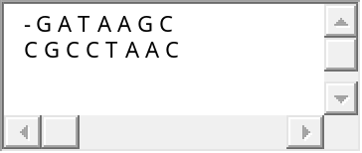  And has only one space segment of length 1, 3 matches and 4 mismatches.  Its value is 1^2⋅(−20)+3⋅15+4⋅(−3)=13 .

Time limit: 3000 ms
Memory limit: 512 MB

